**Assignment Set no. 3**

**Playing with files**

1. . Create a file like nano file1.txt .

* Edit some data and then save the file.

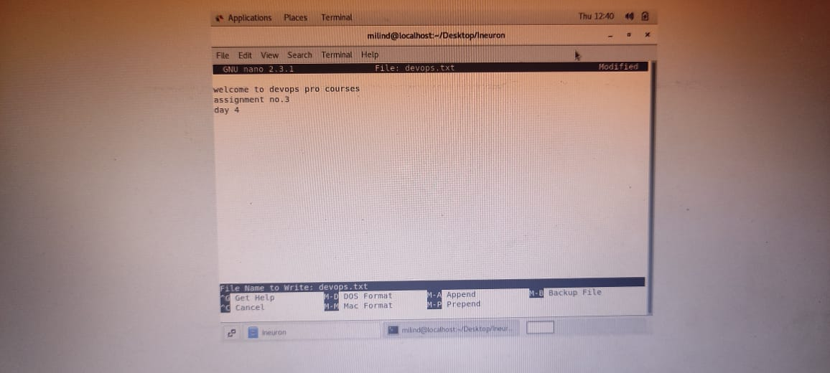



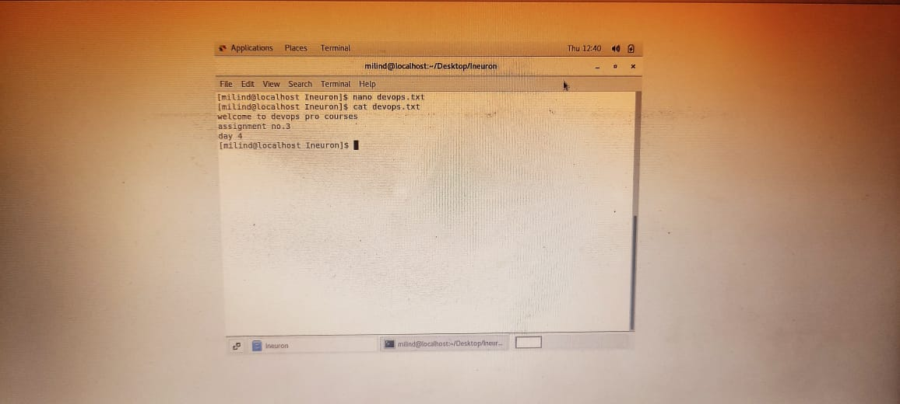

**2)**. **Now we will copy date from file1 to new file2 o cp file1.txt file2.txt**

* **Then see the output of file2.txt, cat file2.txt**

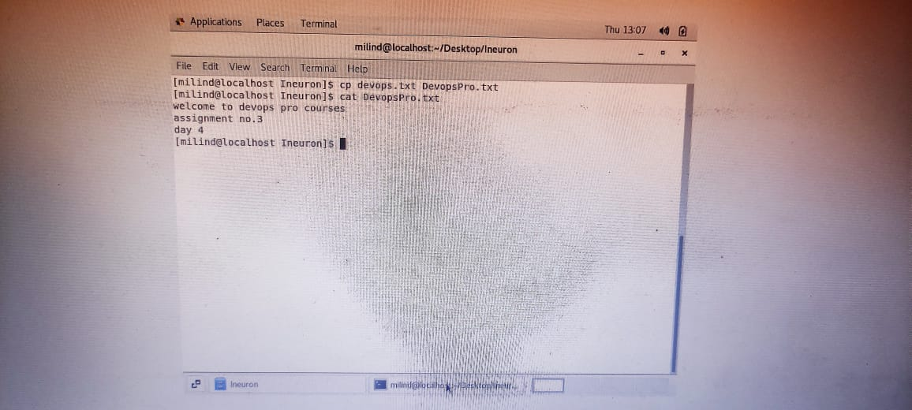

1. **Now we will move the file2.txt to new folder /home o mv file2.txt /home**

* **Then go to home directory and check ls, file exits or not?**

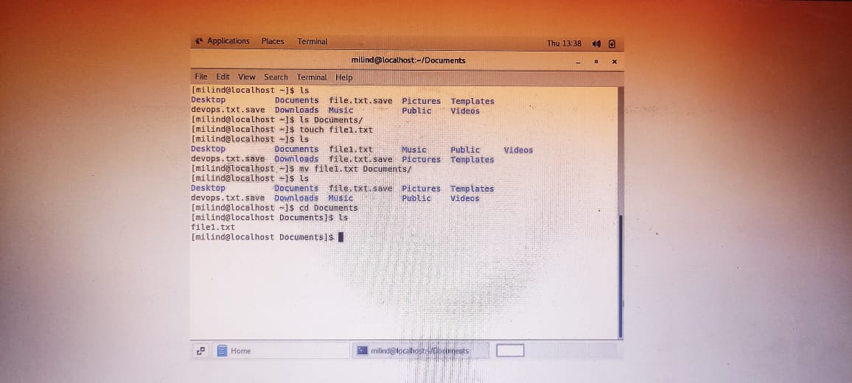

**4)Then we create a new file3.txt and file4.txt in home directory and add content in it.**

* **Now do echo “Hello I am newline” > file3.txt and provide the output of file3.txt**
* **Now do echo “Hello I am newline” >> file4.txt and provide the output of file4.txt**

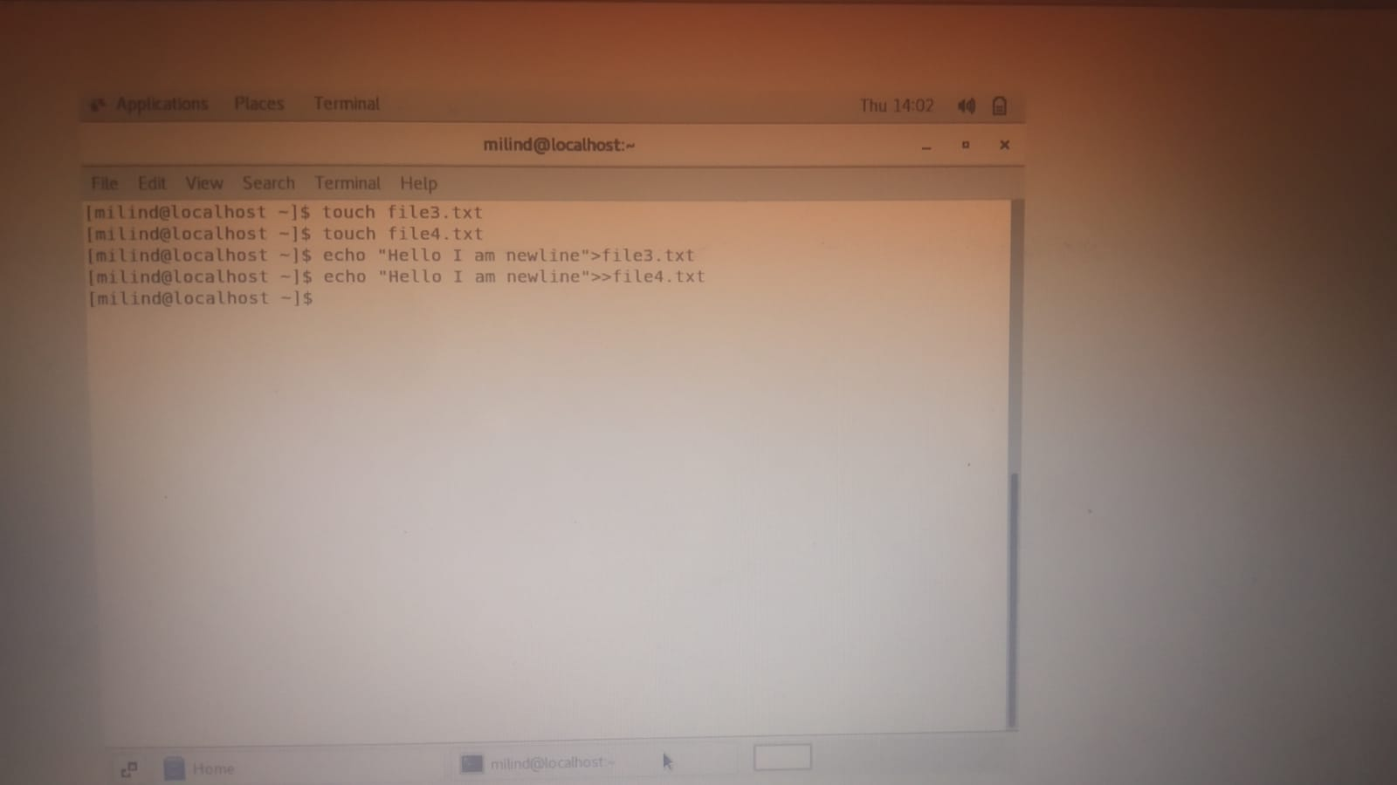

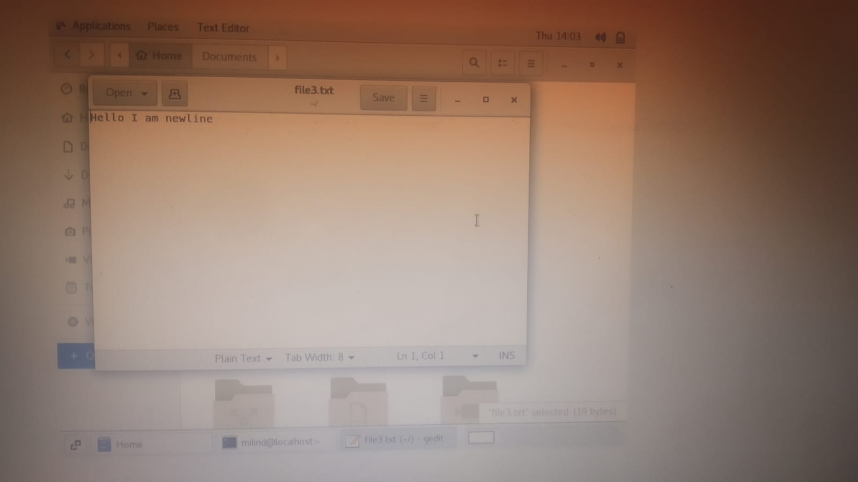

1. **For remove a file or directory you can use the below two commands**

* **To delete a file – rm <any_filename>**

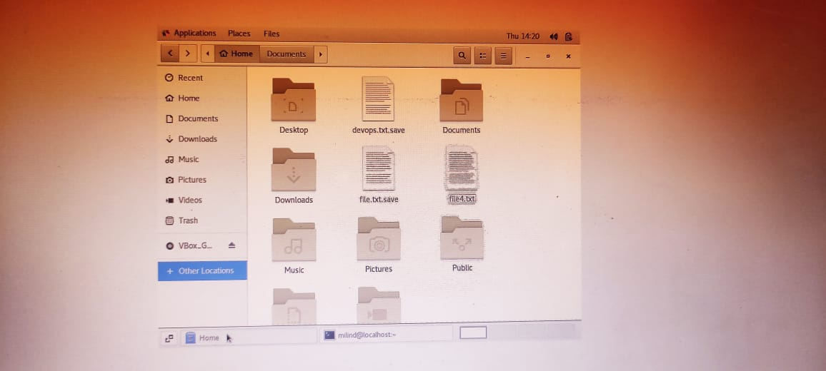

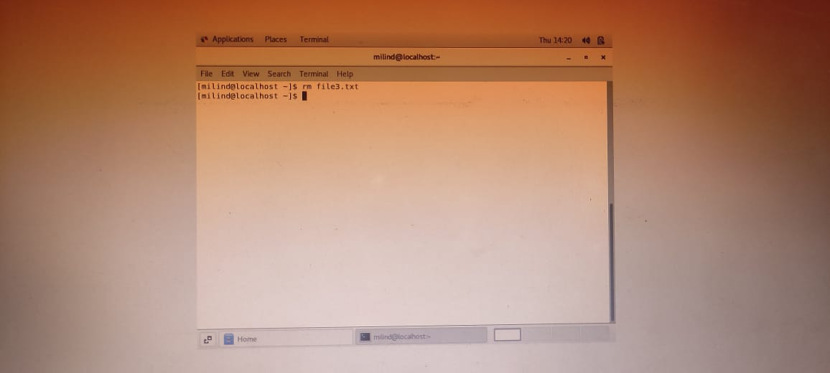

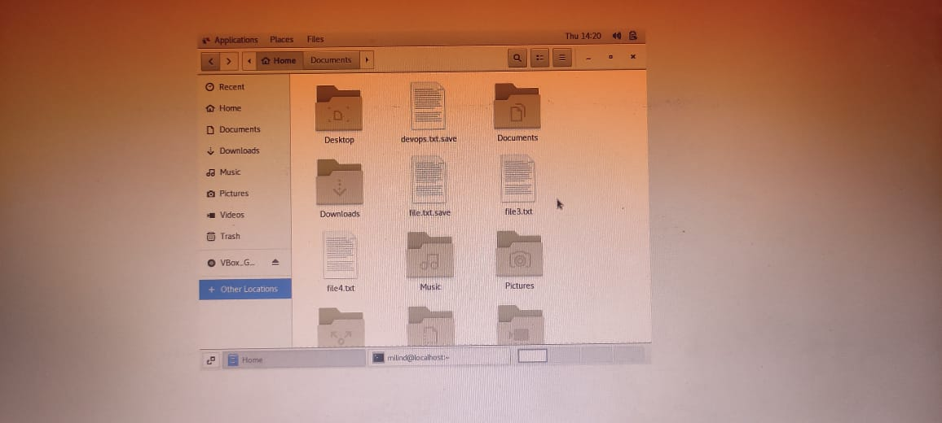

* **To delete a directory - rmdir < any _ directory name >**

